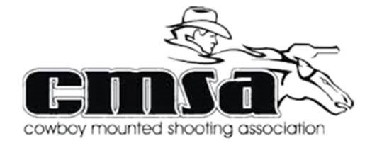
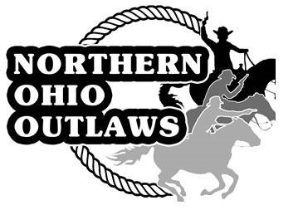
Northern Ohio Outlaws

Cowboy Mounted Shooting Association

2024 Competition Season Sponsorship

Come Ride Fast and Shoot Straight with the Outlaws

Cowboy Mounted Shooting is the fastest growing equestrian sport in the nation. Contestants compete on horseback using two 45 caliber single action revolvers, each loaded with five rounds of specially prepared black powder blank ammunition. Mounted Shooting is a competitive sport with multiple levels of competition ranging from beginner (level 1) to advanced (level 6) as well as a youth division known as Wranglers.
The Northern Ohio Outlaws is affiliated with the Cowboy Mounted Shooting Association (CMSA) and is comprised of members throughout Ohio and neighboring states. Each year the club hosts events throughout the year such as new-shooter clinics, Cowboy Mounted Shooting demonstrations and CMSA sanctioned competitions. This year we will once again be hosting the Ohio State Championship shoot. Competitions typically draw over 100 competitors as well as spectators from all over the country to the Wayne County Fairgrounds in Wooster, Ohio.
As our membership continues to grow it creates an outstanding opportunity for organizations such as yours to receive recognition by becoming a sponsor. Becoming a sponsor will provide advertising opportunities directly to competitors, their families as well as spectators to support your business. We welcome both financial and/or product donations as a form of sponsorship.
Thank you for considering a sponsorship with the Northern Ohio Outlaws. We look forward to building a partnership with you as well as the opportunity to promote your business at our events for the upcoming competition season. Please consider one of our current sponsorship packages listed on the following page.
Sincerely,
Dwayne Jonner, President
Northern Ohio Outlaws
Northern Ohio Outlaw Sponsorship Levels
* Basic sponsors will receive an invitation to our year-end awards banquet at a reduced rate and
will be recognized during the awards ceremony.
$150-$249 Associate Level
- Special mention at all Northern Ohio Outlaw (NOO) events
- Up to a 3' tall banner (any length) supplied by sponsor with company logo at all NOO events.
- Image of business card on website
- Company logo and special URL link to sponsor site on NOO Website
- Invitation to year-end club awards banquet for recognition (at discounted rate)
$250-$499 Friend Level
- Associate level plus the following:
- Small business image on sponsor page
- Opportunity to sell/promote products at all NOO events. Vendor fee will be waived.
- One-Day Shoot is named after your company.
- Invitation to year-end club awards banquet for recognition (at discounted rate)
$500-$999 Patron Level
- Friend level plus the following:
- Sponsorship Appreciation Plaque
- Complimentary invite to year end banquet for recognition
Exclusive Sponsorship Levels
* Exclusive sponsors receive a Northern Ohio Outlaws Sponsorship plaque and a complimentary
invite to the year-end awards banquet for special recognition.
$1000-$1999 Silver Level
- Patron sponsor level plus the following:
- Barrel cover with the company logo supplied by NOO.
$2000-$2999 Gold Level
- Bronze Sponsor Level plus the following:
- Shoot named after your organization for the entire weekend (State Shoot excluded)
$3000 + Platinum Level
Silver Level plus the following:
- Barrel cover with the company logo
- Large (3'X 5') Banner with company/logo at all NOO events
- Business image and URL link to sponsor site on NOO Website
- Business image on sponsor page
- Opportunity to sell/promote products at all NOO events. Vendor fee will be waived.
- Special mentions at all NOO events
- Links and posts made on NOO Facebook page with over 1,000 members to promote your business a minimum of 12 times throughout the year.

Questions: Please Reach out to President Dwayne Joyner joyner@sssnet.com, Vice President Tony Ruper rupersranch@gmail.com or email northernohiooutlawsinfo@gmail.com

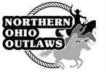
2024 Northern Ohio Outlaws
Sponsorship Form

Date: __________________
Business Name:
Contact Name: __________________________________________________
Mailing Address: _________________________________________________
Phone: __________________ Fax: __________________
Email: __________________________________________________________
Outlaw Member Contact: __________________________________________

Basic Sponsorship Levels
Associate of the Outlaws $150 - $249
Friend of the Outlaws $250 - $499
Patron of the Outlaws $500 - $999

Exclusive Sponsorship Levels
Silver Level Sponsor $1000 - $1999
Gold Level Sponsor $2000 - $2999
Platinum Level Sponsor $3000 +

Financial Donation Amount $___________ Check # ___________ Cash ___________
Goods/Services Amount: $___________
Goods/Services Description: ______________________________________________________________
_____________________________________________________________________________________

**Please make checks payable to Northern Ohio Outlaws**
Mail to: Mark Maxwell, NOO Treasurer, 13395 Toms Rd, Bellville, Ohio 44813

*** All sponsors are responsible to provide artwork to the Northern Ohio Outlaws

Email artwork and a description of your business (to be read at events) to joyner@sssnet.com

