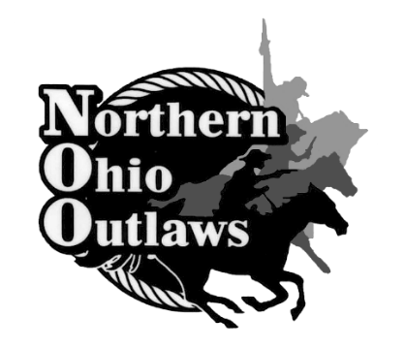
Northern Ohio Outlaws
Balloon Setters

We need you!
As the 2024 season approaches, we are in search of one of the most important factors to run our events. Balloon setters are the key component to complete our monthly competitions in a timely matter. It is a great way for you as a group to raise money for your team, club, and origination. It’s our way to give back to the community and also support our local educational programs.
The Northern Ohio Outlaws host all of our summer shoots in Wooster, Ohio at the Wayne County Fairgrounds. The shoots start in May and normally end with the Ohio State Shoot in August. Cowboy mounted shooting is the fastest-growing equestrian sport in the nation. Mounted contestants compete in this fast-action timed event using two .45 caliber single-action revolvers, each loaded with five rounds of specially prepared blank ammunition. As the cowboy or cowgirls race through the stage, they are shooting at a 12-inch balloon target. A missed balloon adds a five-second penalty to their overall time for that stage. After the stage is completed, the arena is reset with fresh balloons and ready for the next competitor.
How to sign up?
You can contact a director listed below, visit the website at (www.nooutlaws.com ), and/or on our Facebook page (Northern Ohio Outlaws CMSA). We run two arenas at the same time and there is a two-stage shoot on Friday nights. Followed by a four-stage main shoot, two-stage rifle, and two-stage shotgun on Saturdays and a four-stage shoot on Sundays. Your club has the option of setting balloons for one arena or both on either Friday, Saturday, or Sunday. The balloon setters get paid $3.00 per shooter/per stage.
Get prepared!
We recommend having at least 10 people per arena. That includes adults and kids working together as a team to blow up balloons, setting balloons, and cleaning balloon pieces up in the arenas. Dress for the weather, we run rain or shine. There is a food vendor present, but you are more than welcome to bring your food and drinks. Bring chairs, popup tents, tables, etc. Directors will be at the events to guide you where to go. We will provide you with a packet of safety instructions to follow while working during the shoot. You can also keep it and use it in the future if you are a returning balloon setter. For more additional information, feel free to ask!!
Contact us today if interested!
Lynn Bussell Cell 330-242-3452 Kathy Zadra 330-988-4692
2024 Shoot Dates:
April 27th -28th June 8th -9th July 5th-7th
August 3rd -4th September 28th -29th

